

CLOUD COMPUTING LAB
BSE ( V-B )

Submitted By:
Musfira Farooq
Roll No:
2023-BSE-045
Submitted To:
Sir Muhammad Shoaib

LAB 11

GH CLI Codespaces + AWS + Terraform: Variables, Collections, Sensitivity & EC2 Provisioning

Task 0 – Lab Setup (Codespace & GH CLI)
- Codespace Creation and Listing Output
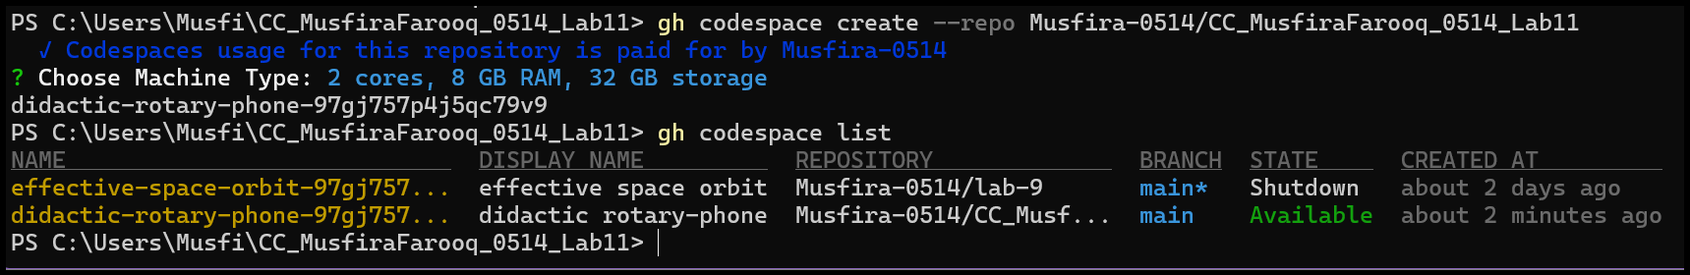
- Codespace SSH Connection Terminal
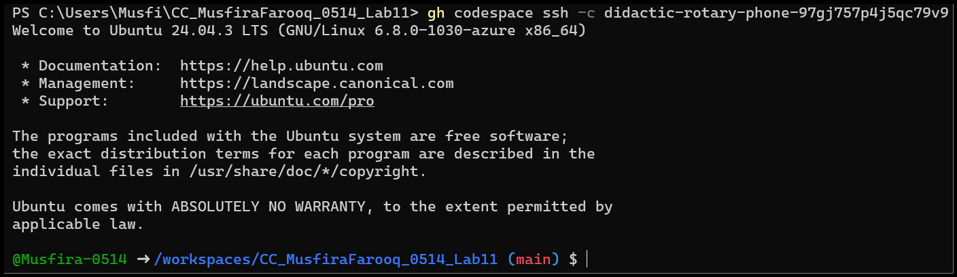
Task 1 – Provider & Basic Variable (Variable Precedence)
- main.tf File Creation
- AWS Provider Block Added
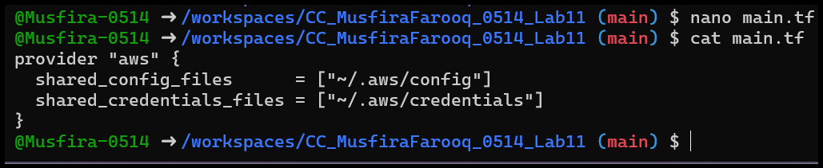
- Terraform Initialization Output
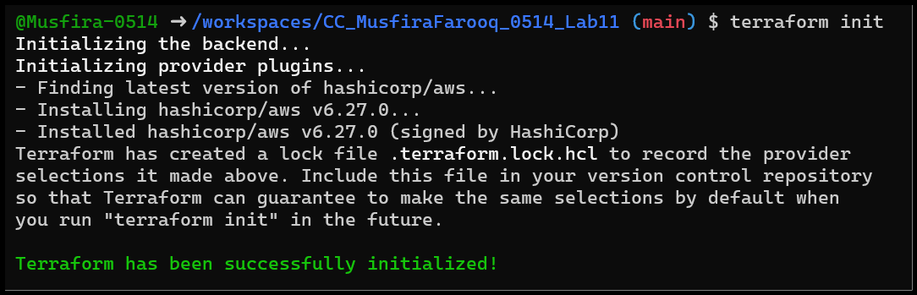
- Variable and Output Blocks Added
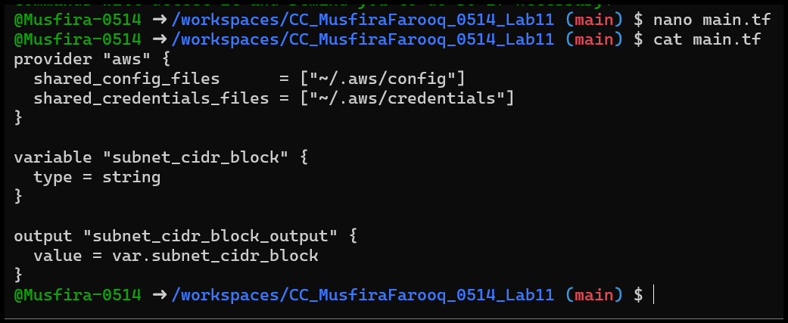
- Terraform Apply Prompting for Variable Input
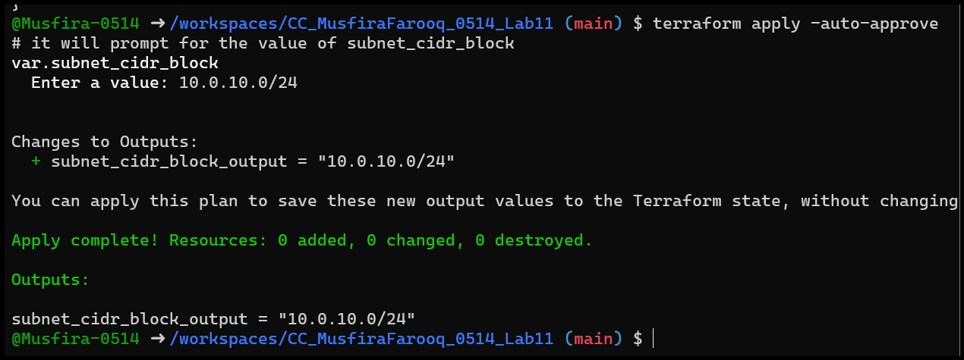
- Terraform Apply Using Default Value
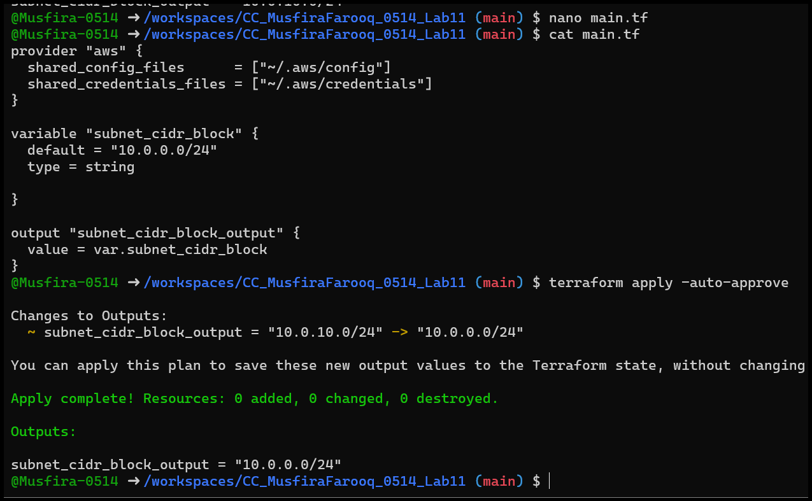
- Apply with Environment Variable TF_VAR
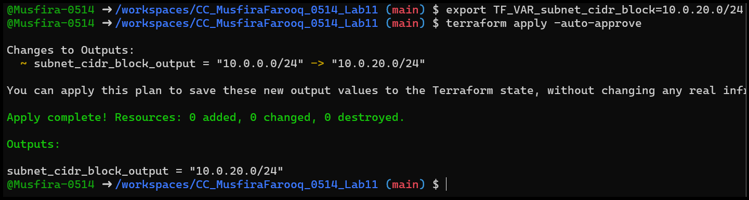
- Apply Using terraform.tfvars Values
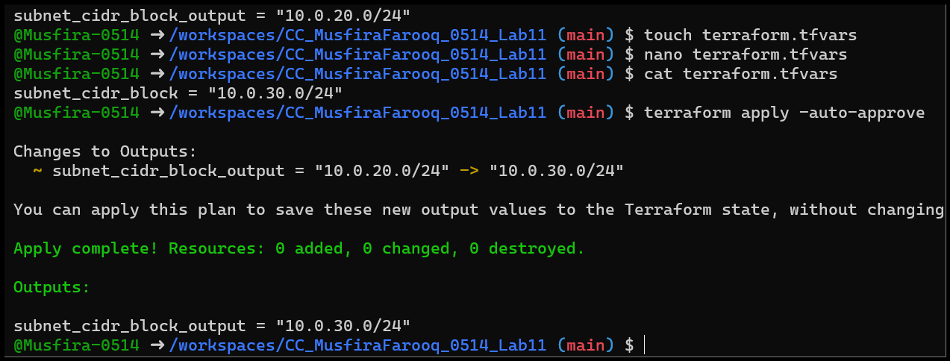
- Apply with -var Override
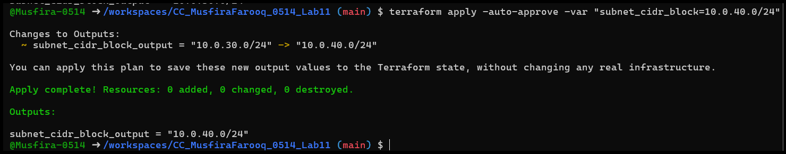
- TF_VAR Environment Variable Before and After Unset
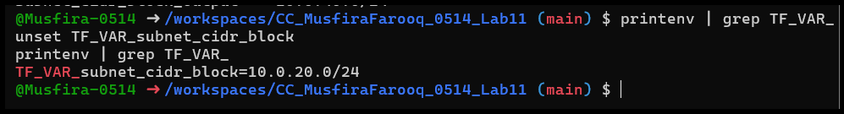
Task 2 – Variable Validation & Sensitive/Ephemeral Variables
- Subnet CIDR Variable with Validation
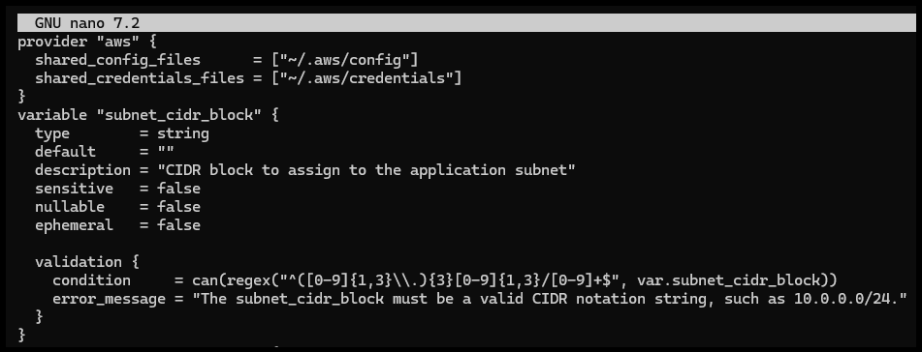
- Validation Error for Invalid Subnet CIDR
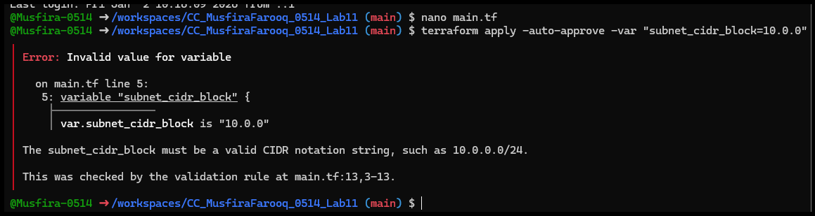
- Sensitive API Session Token Variable Added
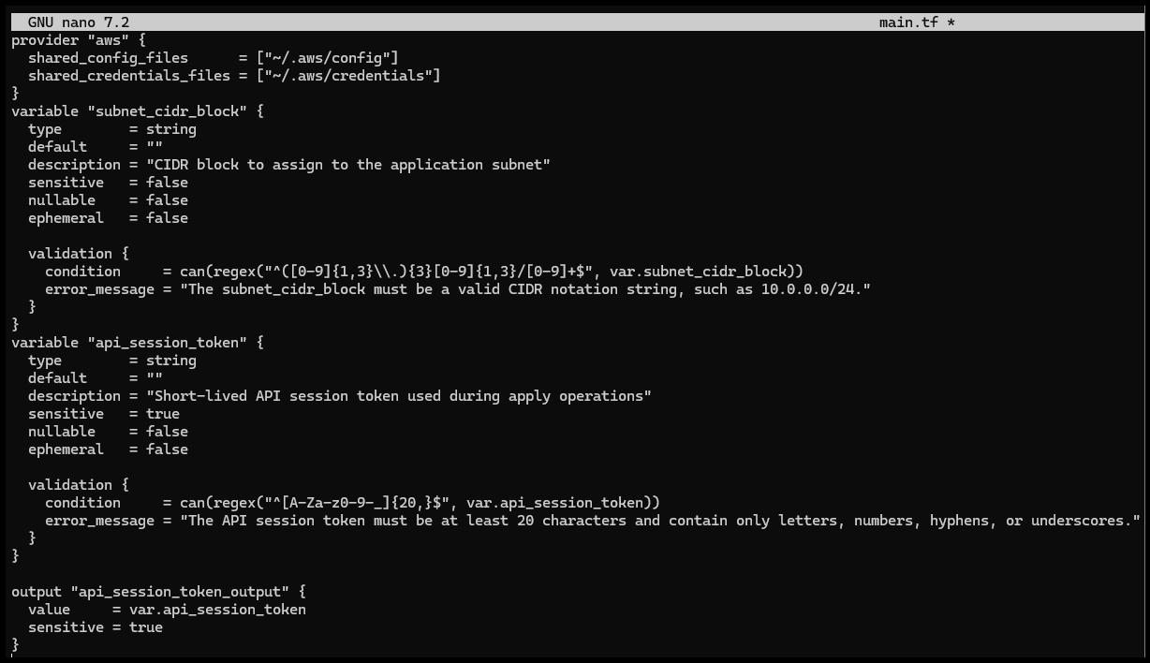
- Apply Output Masking Sensitive Variable
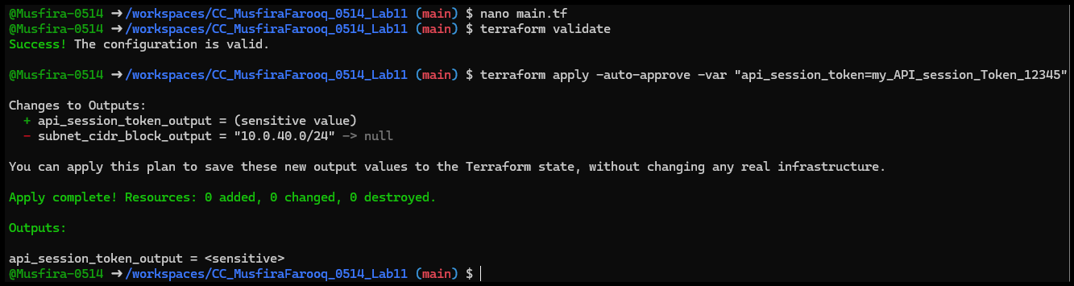
- Terraform State Showing Sensitive Output
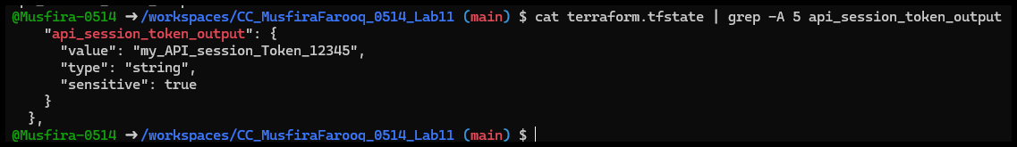
- Behavior/Error with Ephemeral Variable
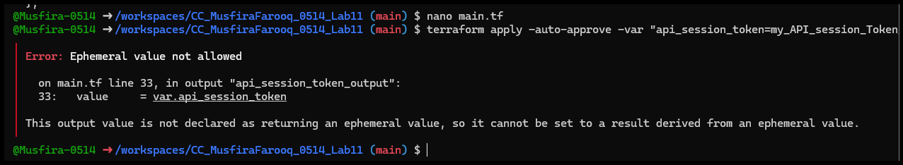
- Apply Output with Default Sensitive Value
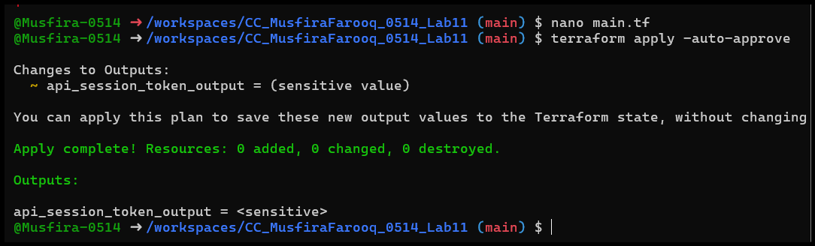
Task 3 – Project-level Variables, Locals, and Outputs
- Project-level Variables Added
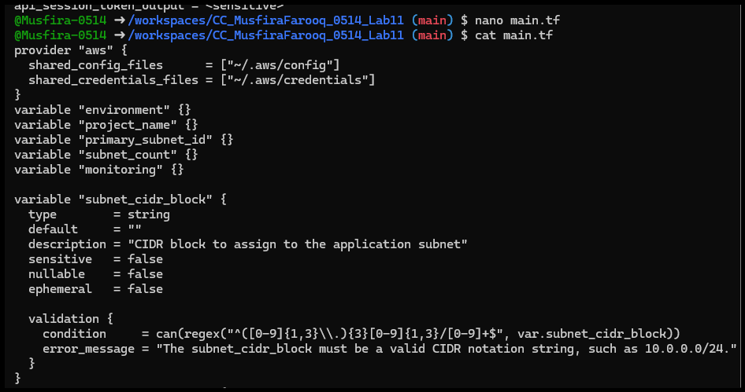
- terraform.tfvars Populated with Subnet ID and Other Values
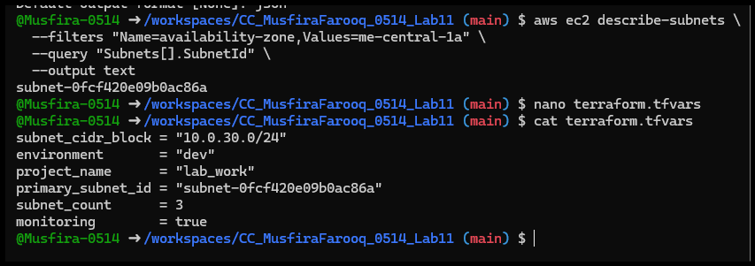
- Locals.tf with Computed Values
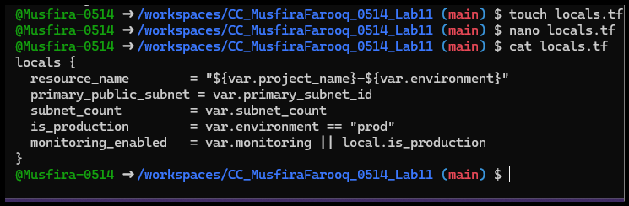
- Terraform Apply Showing Outputs
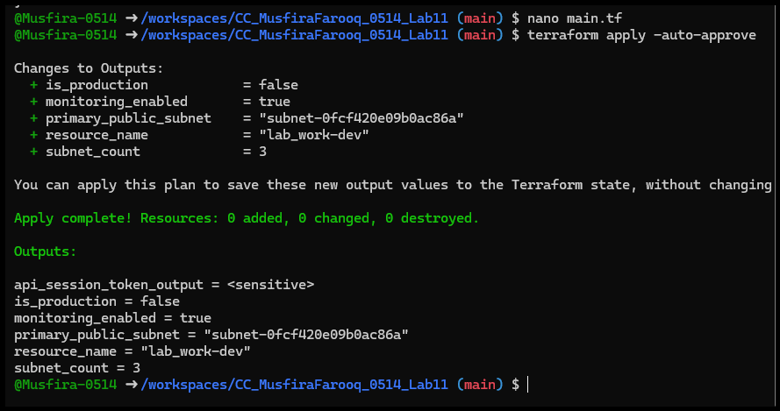
Task 4 – Maps and Objects
- Tags Map Variable and Output Added
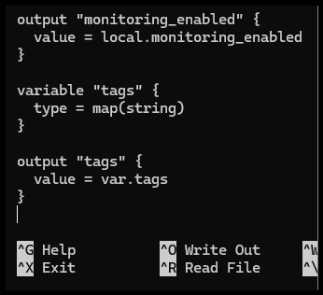
- Terraform Apply Showing Tags Output
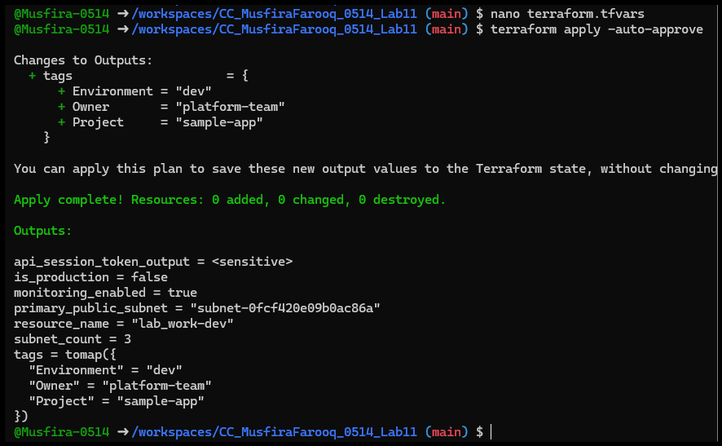
- Terraform Apply Showing Server Config Object
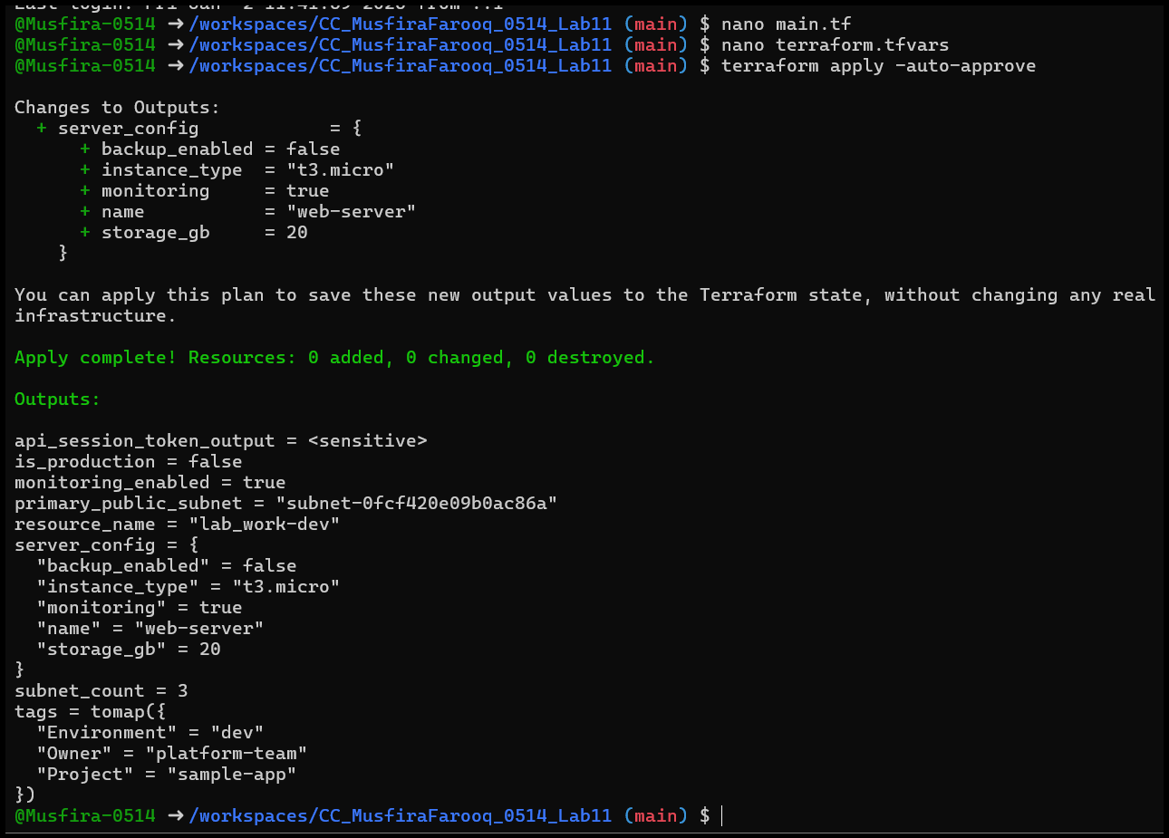
Task 5 – Collections: List, Tuple, Set & Mutation via Locals
- Collection Variables and Comparison Output Defined
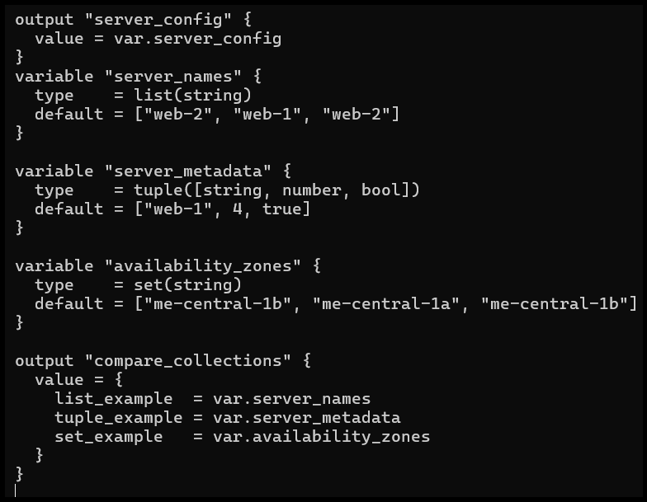
- Terraform Apply Comparing Collections
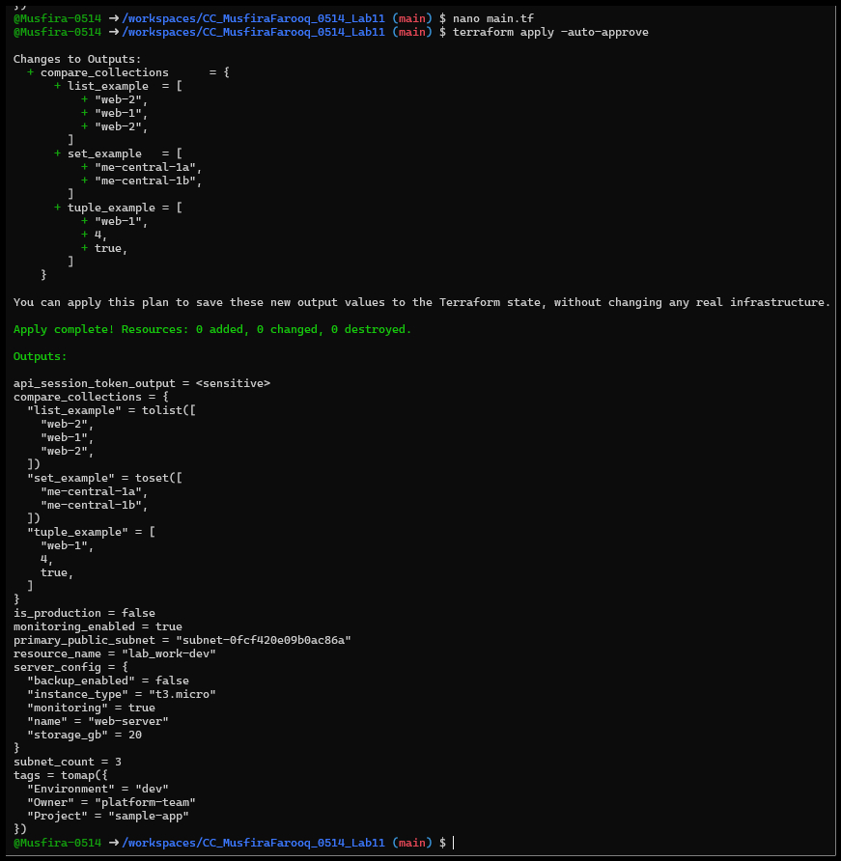
- Locals.tf Showing Mutated List, Tuple, Set
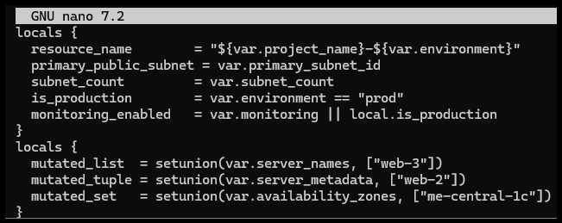
- Apply Output Comparing Original and Mutated Tuple
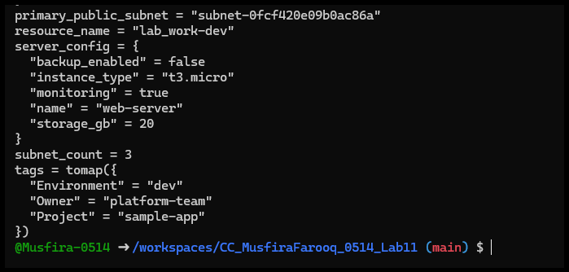
Task 6 – Null, Any Type & Dynamic Values
- Optional Tag Variable Added
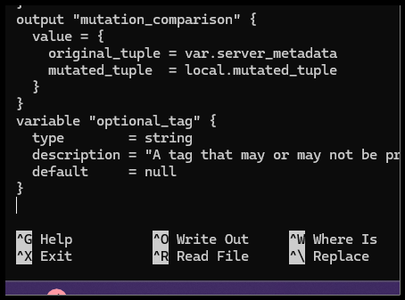
- Locals.tf Merge Logic
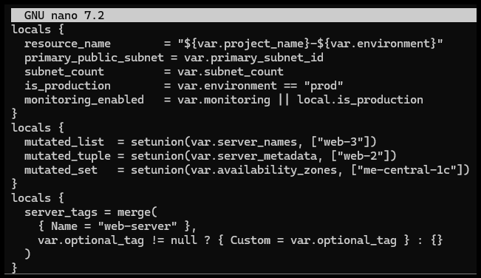
- Apply Output with No Optional Tag
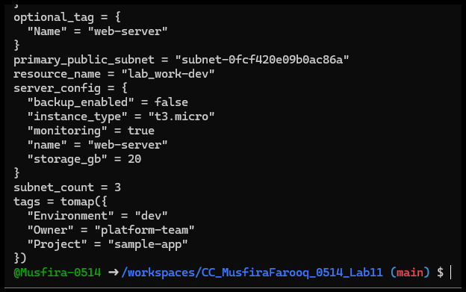
- Apply Output with Optional Tag Set
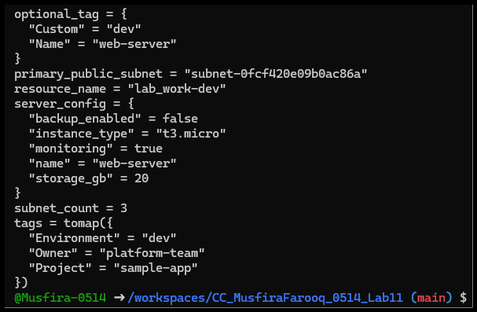
- Dynamic Value as String
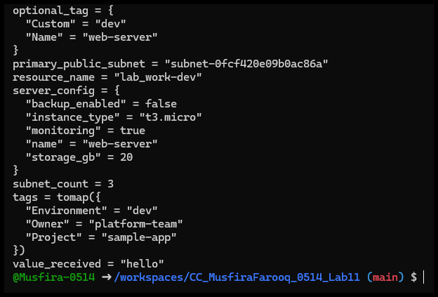
- Dynamic Value as Number
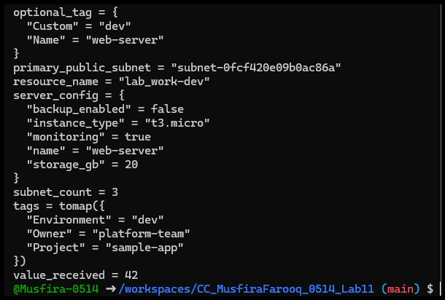
- Dynamic Value as List
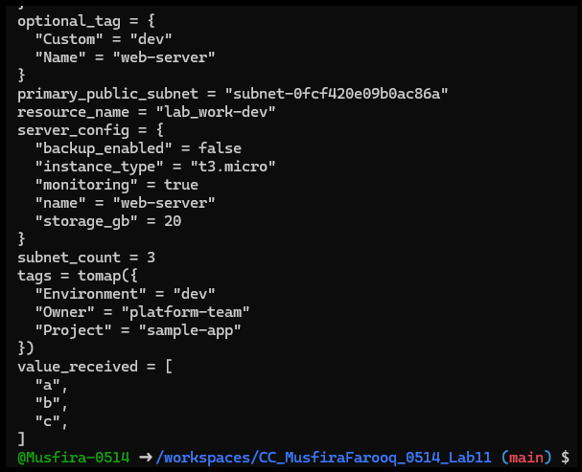
- Dynamic Value as Map/Object
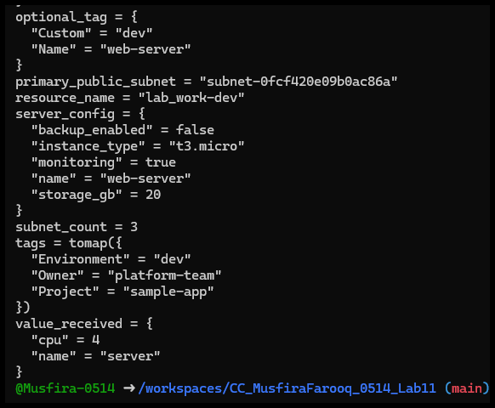
- Dynamic Value as Null
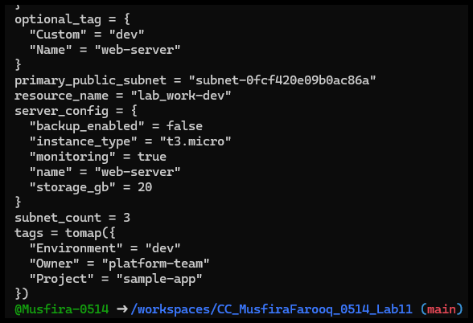
Task 7 – Git Ignore
- .gitignore File Created with Terraform and PEM Exclusions
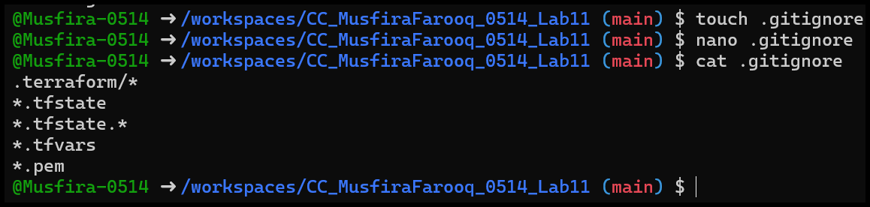
Task 8 – Clean-up then Build Real Infra (VPC, Subnet, IGW, Routing, Default Route Table)
- Cleaned terraform.tfvars, locals.tf, and main.tf
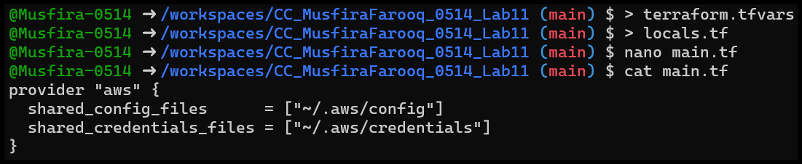
- Variables Recreated for VPC and Subnet
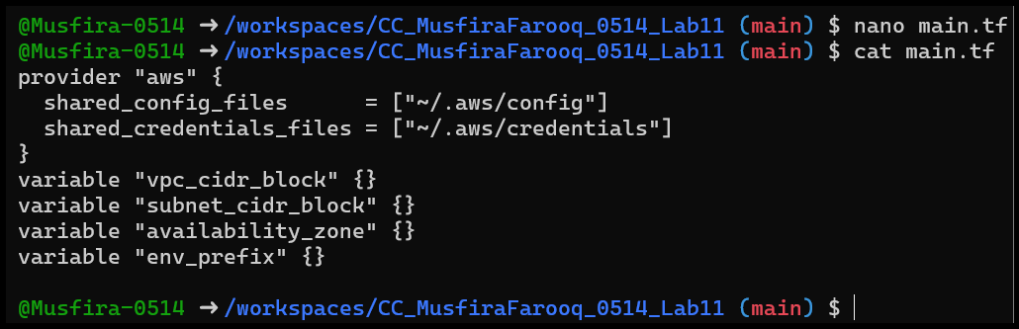
- AWS VPC Resource Added
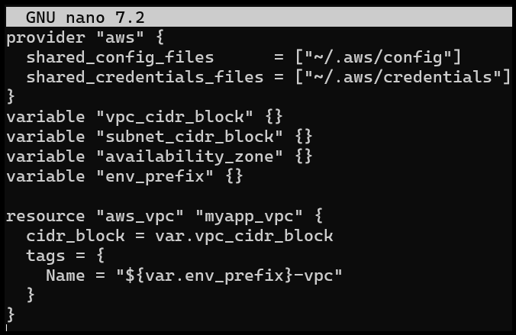
- AWS Subnet Resource Added
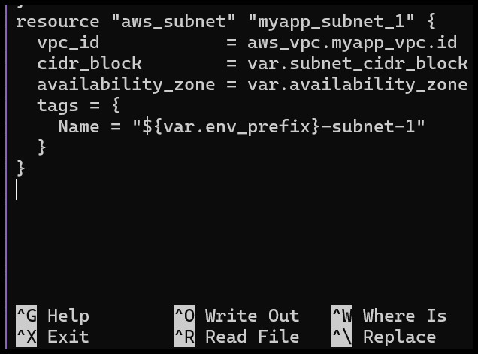
- terraform.tfvars with VPC and Subnet Values
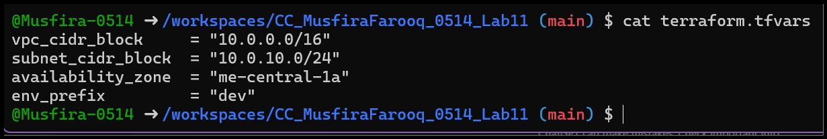
- Apply Output Showing VPC and Subnet Creation
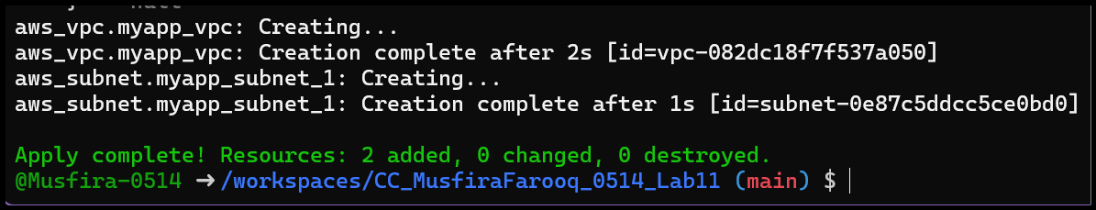
- AWS Console Showing IGW and Route Table Before Apply
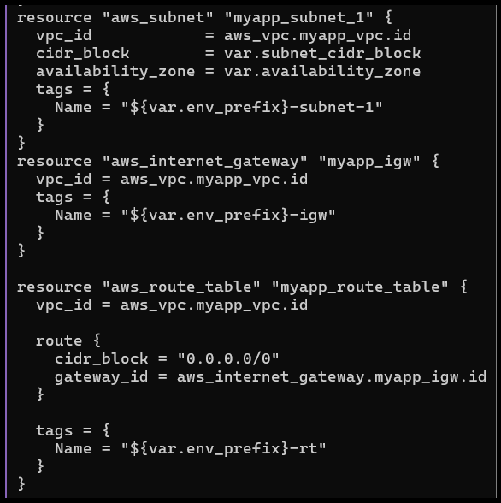
- Terraform Apply Showing IGW and Route Table Creation
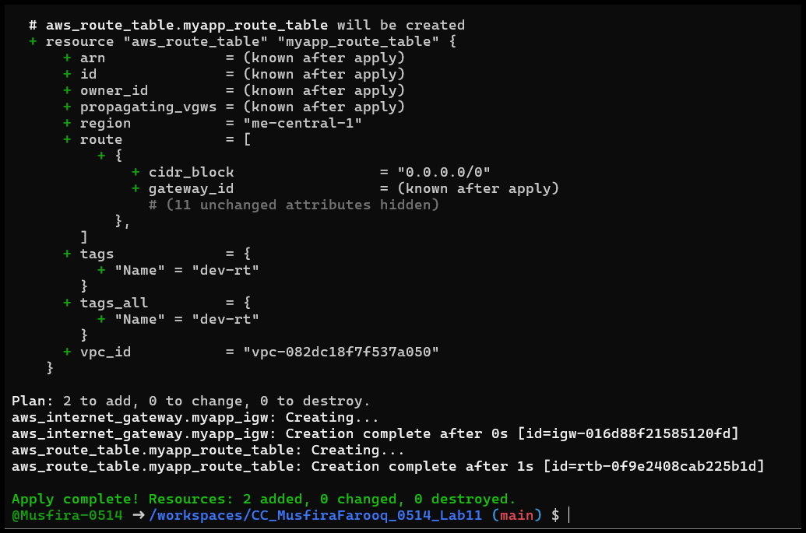
- Default Route Table Resource Added
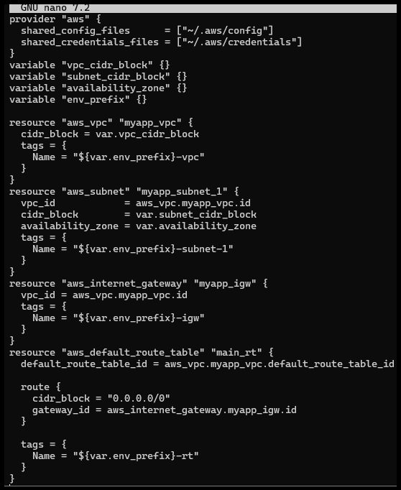
- Apply Output Showing Default Route Table Updated
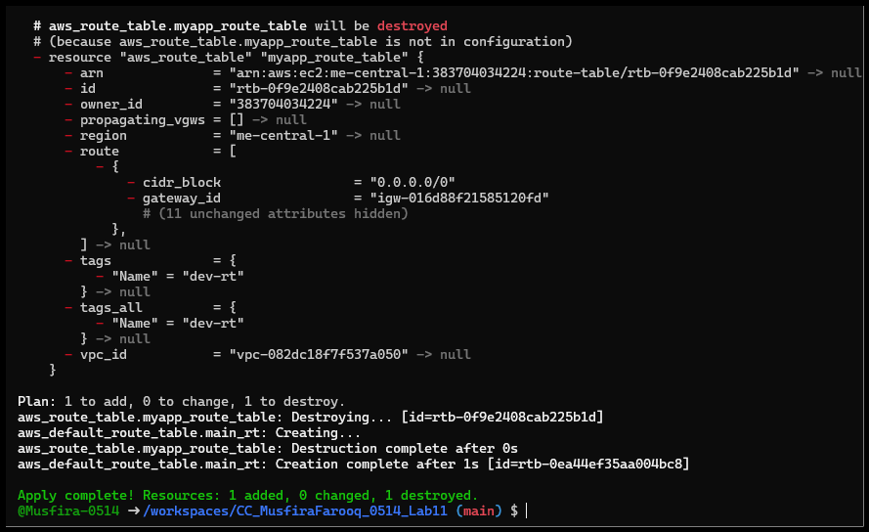
Task 9 – Security Group, Key Pair, EC2 Instance, user_data & Nginx
- my_ip Variable Added
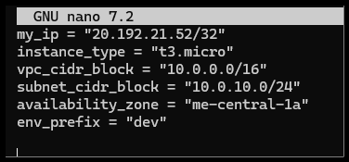
- Public IP Retrieved via curl and terraform.tfvars Updated
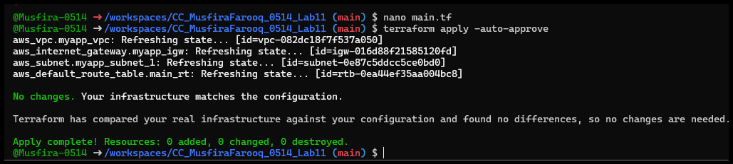
- Security Group Resource Added and Applied
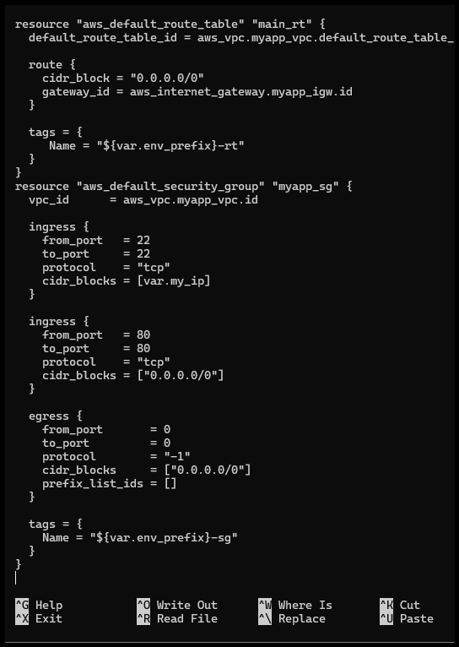
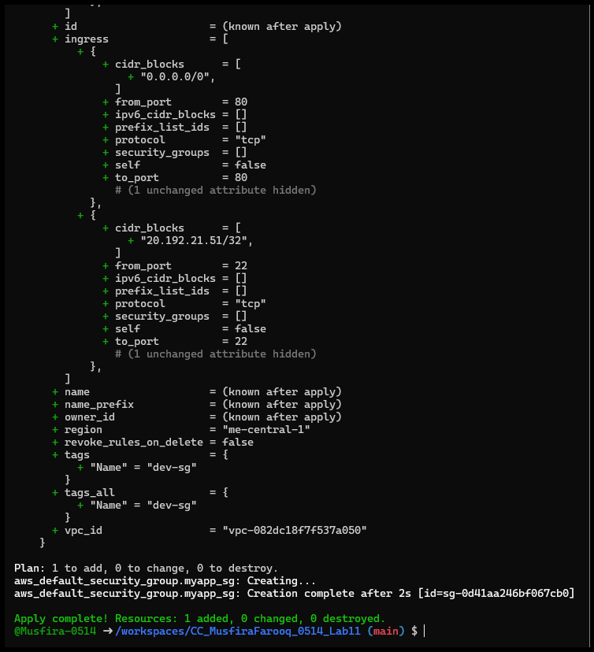
- Key Pair Created and Saved Locally
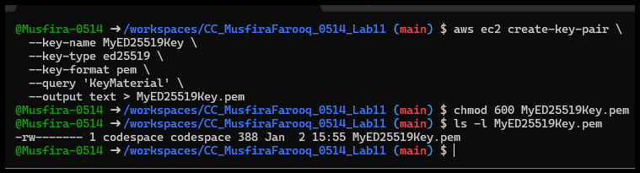
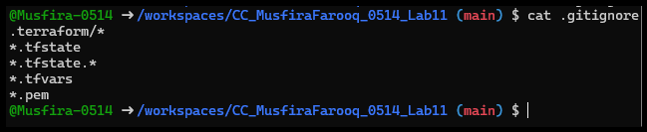
- EC2 Instance Resource Defined with Instance Type
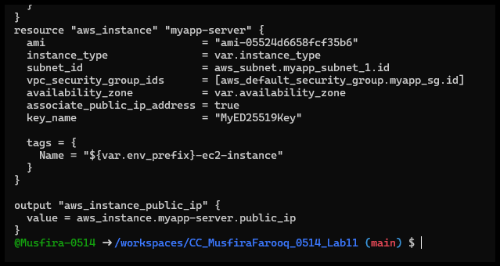
- EC2 Instance Applied and Public IP Shown
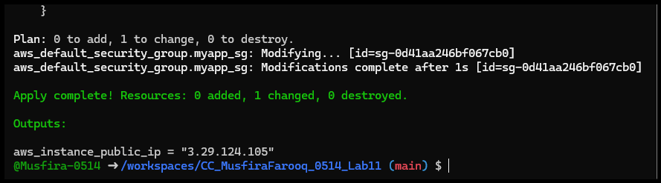
- SSH into EC2 Instance
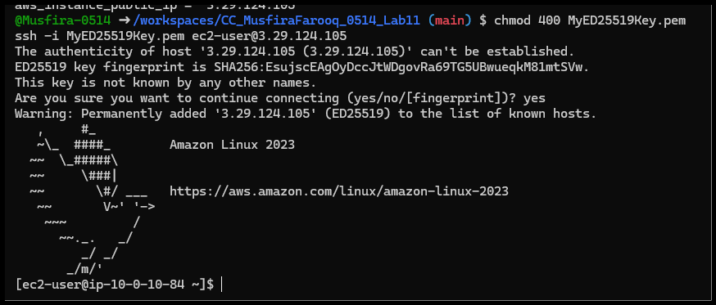
- Terraform-Managed SSH Key Pair Applied and SSH Verified
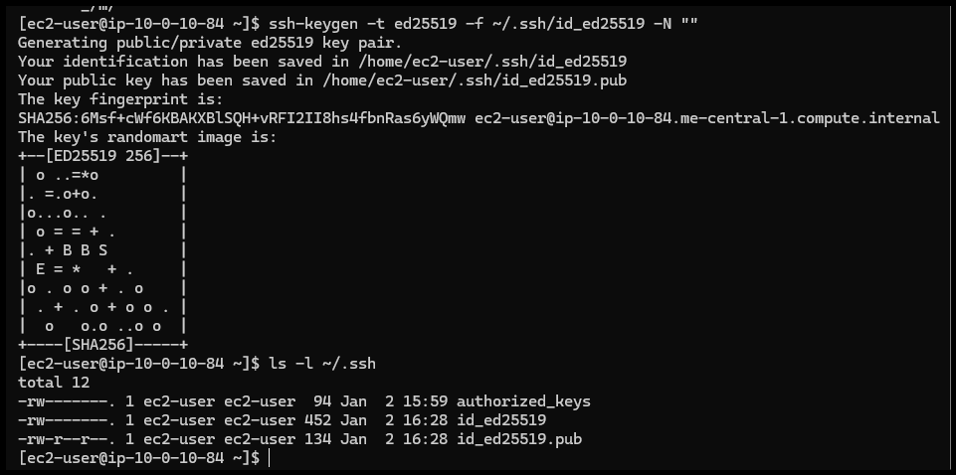
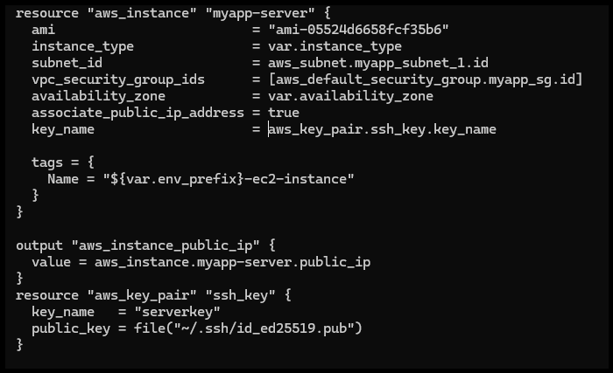
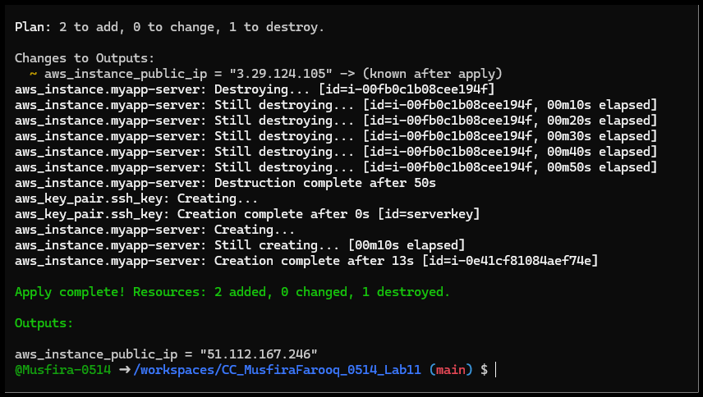
- Nginx Installed via user_data, curl localhost Response
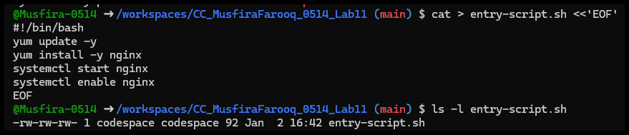
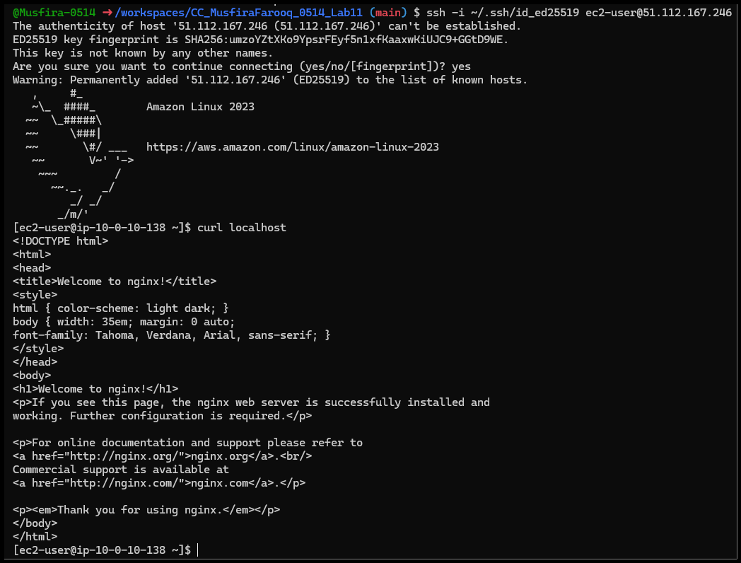

- Nginx Default Page Shown in Browser
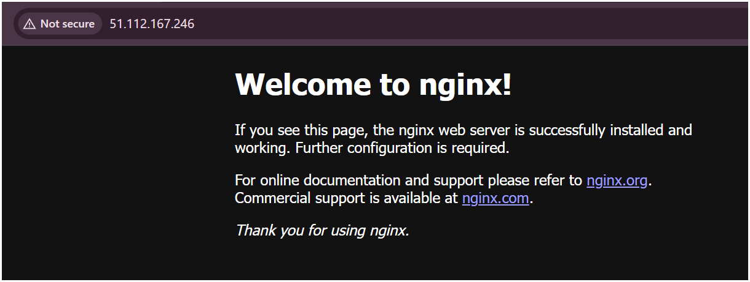

Cleanup
- Terraform Destroy Output
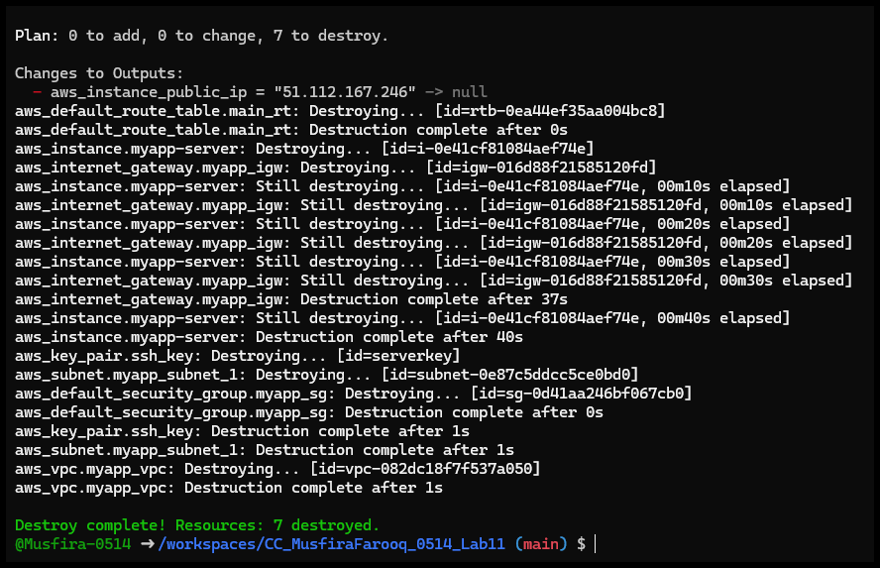
- State Files After Cleanup
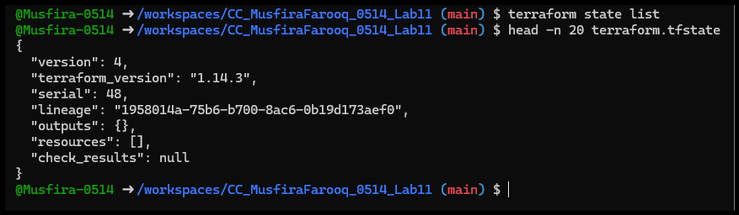
- Git Status and .gitignore Confirming No Secrets Staged
